

User Manual Structure Guidelines Cover

* Document title, authors, institution ID, date (copyright info)

VaxCare

Backloggers

João Castro, Gustavo Jorge, João Leitão, Guilherme Sousa, Pedro Monteiro

1210816, 1211061, 1211063, 1211073, 1211076

ISEP LEI

19/06/2022

Glossary Relevant terms and abbreviations used in the document

**Glossary**

|  |  |  |
| --- | --- | --- |
| Terms or Expression (EN) | Termo ou Expressão (PT) | Description(EN) |
| Administrator | Administrador | A person responsible for carrying out the administration of a business or organization |
| Adverse Reactions | Reações Adversas | An adverse effect is an undesired harmful effect resulting from a medication or other intervention, such as surgery. |
| Algorithm | Algoritmo | A step-by-step procedure for solving a problem or accomplishing some end. |
| Application User | Utilizador da Aplicação | A person that is going to use the application as a client. |
| Application | Aplicação | A program that performs a particular task or set of tasks. |
| Asymptotic Behavior | Comportamento Assintótico | The asymptotic behavior of sequences of random variables, that is the behavior of infinitely long sequences of random variables, is an involved mathematical concept but it has important implications for the statistical analysis of data from large samples. |
| Benchmark Algorithm | Algoritmo de Referência | In statistical learning benchmarking is the methodology of comparing learners or algorithms with respect to a certain performance measure. |
| Brute-Force Algorithm | Algoritmo de Força Bruta | In computer science, brute-force search or exhaustive search, also known as generate and test, is a very general problem-solving technique and algorithmic paradigm that consists of systematically enumerating all possible candidates for the solution and checking whether each candidate satisfies the problem’s statement. |
| CamelCase | CamelCase | CamelCase is a naming convention in which a name is formed of multiple words that are joined together as a single word with the first letter of each of the multiple words capitalized so that each word that makes up the name can easily be read. |
| Centers | Centros | The point from which an activity or process is directed, or on which it is focused. |
| Client | Cliente | A person served by or utilizing the services of a social agency. |
| Computation Complexity | Complexidade Computacional | In computer science, the computational complexity of an algorithm is the number of resources required to run it. Focus is given to time and memory requirements. |
| Contiguous | Contíguo | Being in actual contact: touching along a boundary or at a point. |
| Coordinator | Coordenador | A person whose job is to organize events or activities and to negotiate with others to ensure they work together effectively. |
| Default | Predefinição | A preselected option adopted by a computer program or other mechanism when no alternative is specified by the user or programmer. |
| Digital Certificate | Certificado Digital | An official document that states that the information on it is true, however it’s in a digital format. |
| Dosage Scheme | Esquema de Dosagem | The size, frequency, and number of doses of a given vaccine. |
| Employee | Funcionário | A person employed for wages or salary, especially at non-executive level. |
| Entries and Exists List | Lista de Entradas e Saídas | List of people that have entered and exited the vaccination center. |
| FIFO Queue | Fila FIFO | A FIFO Queue is a queue that operates on a first-in, first-out (FIFO) principle. This means that the request (like a customer in a store or a print job sent to a printer) is processed in the order in which it arrives. |
| GHD | DGS | Acronym for General Health Directorate. |
| GRHC | AGES | Acronym for Groupings of Health Centers. |
| Given Vaccine | Vacina Administrada | The Vaccine that was administered to the patient. |
| Healthcare Center | Centro dos Cuidados de Saúde | A healthcare center is one of the network of clinics staffed by a group of general practitioners and nurses providing healthcare services to people in a certain area. |
| JUnit5 | JUnit5 | JUnit 5 is the updated version of the highly popular testing library for Java applications, JUnit. |
| JaCoCo | JaCoCo | JaCoCo runs as a Java agente. It’s responsible for instrumenting the byte code while running the tests. JaCoCo drills into each instruction, and shows which lines are exercised during each test. |
| JavaFX11 | JavaFX11 | JavaFX is a modern, efficient, and fully featured toolkit for developing rich client applications. |
| JavaDoc | JavaDoc | JavaDoc is a documentation tool for the Java programming language. The document it creates from the Java sources is in HTML format and describes the application programming interface. |
| Mass Vaccination Center | Centro de Vacinação em Massa | Mass vaccination centers are like healthcare centers but usually only administer one type of vaccine during pandemic events. |
| NHS | SNS | Acronym for National Health Service. |
| Nurse | Enfermeira | A person skilled or trained in caring for sick or injured people. |
| Outbreak | Surto | A sudden rise in the incidence of a disease. |
| Performance | Desempenho | The execution of an action. |
| RHA | ARS | Acronym for Regional Health Administration. |
| Receptionist | Rececionista | A receptionist is an employee taking an office or administrative support position. |
| SMS | SMS | Acronym for Short Message Service. |
| SMS User | Utilizador SNS | SNS User is a person that is registered in the SNS system. |
| SVG | SVG | Scalable Vector Graphics (SVG) is a web-friendly vector file format. As opposed to pixel-based raster files like JPEGs, vector files store images via mathematical formulas based on points and lines on a grid. |
| Slot | Intervalo | A time when something can happen or is planned to happen, especially when it is one of several possible times. |
| System | Sistema | A group of devices or artificial objects or an organization forming a network especially for distributing something or serving a common purpose. |
| Time Complexity | Complexidade Temporal | Time complexity is the amount of time taken by an algorithm to run, as a function of the length of the input. It measures the time taken to execute each statement of code in an algorithm. |
| Type of Vaccine | Tipo de Vacina | Related to the kind of virus that the vaccine cures. |
| User Info | Informação do Utilizador | Health related information about a user. |
| User Waiting List | Lista de Espera de Utilizadores | List of users who are waiting in the vaccination center to be vaccinated. |
| User | Utilizador | A person who uses or operates the application. |
| Vaccination Center | Centro de Vacinação | In our case, it includes mass vaccination centers and healthcare centers, linking both because they share the vaccination process. |
| Vaccination Process | Processo de Vacinação | The entire process from start to finish that a user must endure to complete their vaccination. |
| Vaccine Appointment | Agendamento de Vacinas | An arrangement for a meeting with the vaccination center to be administered a vaccine. |
| Vaccine | Vacina | A vaccine is a biological preparation that provides active acquired immunity to a particular infectious disease. A vaccine typically contains an agent that resembles a disease-causing microorganism and is often made from weakened or killed forms of the microbe, its toxins, or one of its surface proteins. |
| SLR | RLS | Stands for simple linear regression. |
| MLR | RLM | Stands for multiple linear regression. |
| GB | GB | Stands for gigabyte and is a size measurement for electronic devices. |
| MB | MB | Stands for megabyte and is a size measurement for electronic devices. |

* Table of contents _ List of sections, numbered, including the start page (index)

1. **Introduction**
   1. Purpose and Scope of this manual

This user manual contains all the useful information regarding the developed application, in the simplest way, so that the users, which are the main target of this document, can easily learn and understand how to use the VaxCare properly.

* 1. System Overview

VaxCare is a health directed application, with the main goal of managing the whole vaccination process of a Healthcare Facility, since immunization is a global health and development success story, that saves millions of lives every year, helping people’s bodies to create defenses against diseases.

The app is structured to allow both people who get vaccinated (SNS Users for example), and people that are engaged in the vaccination process (Nurses, Center Coordinators, Receptionists…).

This product allows its users to schedule vaccinations, consult the list of people waiting and ready to get vaccinated, in an organized and efficient way, register administered vaccines, evaluate the performance and statistics of each vaccination facility, between many other features.

* 1. System Requirements

The application was thought and designed having in mind, that it is supposed to run in almost every single device.

It’s possible to run the application in every operating system since it’s a Maven Java Project.

To be able to run the application, every user must have Java in at least version 8, and JavaFX11.

It is recommended that your device has a minimum RAM 2 GB and at least 100 MB disk space.

* 1. Software Installation

To get VaxCare working properly, follow the steps bellow, carefully, so you can have every requirement fulfilled:

1. Installing Java:
   1. Open your browser and search for Java Download.
   2. Select the [official link](https://www.java.com/pt-BR/download/ie_manual.jsp?locale=pt_BR) for the download like in the image.
   3. Click in the green button that says “Download”.
   4. You’ll be given the latest version of Java download executable.
   5. Save it on your computer and open it.
   6. Follow the download steps you’ll be given, complete the process, and you’re good to go.
2. Installing JavaFX:
   1. Open your browser and search for JavaFX.
   2. Open the JavaFX [official link](https://openjfx.io).
   3. Scroll down until you see a “Download” button and click on it.
   4. Scroll down until you see the many operating system downloads and select the one that matches yours.
   5. You’ll be given the zip file of JavaFX.
   6. Open it and click on the “Extract To” button.
   7. Select the path that contains the previously downloaded Java, and you’re good to go.
3. Running the VaxCare:
   1. After downloading the zip folder of VaxCare, extract it just like when installing JavaFX (*Step 2)* 🡪 *f*.).
   2. Then, open the extracted file, and follow the path XXXX > YYYY > ZZZZ.
   3. There you’ll find the VaxCare jar executable.
   4. Open it and enjoy
4. **System Features** 

**Non-Graphical Interface Features**

* 1. Login:

1. In the main menu, select option ‘1’ that says “Login”.
2. Now you’ll have to start by typing either your email address or your user ID.
3. After the email address, you’ll have to type your password.
   * 1. Login Successful:

A menu for the User’s role is shown.

* + 1. Invalid Email Address:

If the user enters an invalid email address or user ID, the following message will show: “Invalid User ID and/or Password. You have 2 more attempt(s).”

* + 1. Invalid Password:

If the user enters an invalid password, the following message will show: “Invalid User ID and/or Password. You have 2 more attempt(s).”

* + 1. Login Tries Limit Reached:

If the user fails the login 3 times, the system will show the same message (with 0 attempt(s) left) and will redirect you back to the main menu.



**Administrator Features:**

* 1. Register an Employee

*Prerequisite: Login by following step 2.1*

1. Select option “2” in the Administrator Menu.
2. Select a role for the new Employee.
3. Follow the steps bellow to “Register a New Employee”:
   1. Some of the requested data has a specific format or validation. (Follow the step *3.1* in Troubleshooting*).*
      1. Register an Employee Successfully

Both ID and Password for the employee are generated automatically and the new employee is added.

* + 1. Register an Employee Invalid

If any of the employee’s typed information is invalid, the following error message will display:

* 1. Get a List of Employees:

*Prerequisite: Login by following step 2.1*

1. Select option “3” in the Administrator Menu.
2. The user must select the role he wants to get a list of.
   * 1. Get a List of Employees Successfully

If the chosen role’s list of employees is registered in the system, the following message containing the list will display:

* + 1. Get a List of Employees Invalid

If the chosen role’s list of employees isn’t registered in the system, the following error message will display:

* 1. Specify a New Vaccine Type

*Prerequisite: Login by following step 2.1*

1. Select option “4” in the Administrator Menu.
2. Follow the steps bellow to “Specify a New Vaccine Type”.
   1. Some of the requested data has a specific format or validation. (Follow the step *3.6* in Troubleshooting).
      1. Specify a New Vaccine Type Successfully

If all the information is well filled, the following data confirmation and success message will show:

* + 1. Specify a New Vaccine Type Invalid

If the information isn’t well filled, the following invalid data message will display, showing what was filled, redirecting the user back to the Administrator Menu:

* 1. Specify a New Vaccine and its Administration Process

*Prerequisite: Login by following step 2.1*

1. Select option “5” in the Administrator Menu.
2. Select an available vaccine type.
3. Follow the steps bellow to “Specify a New Vaccine Type”.
   1. Some of the requested data has a specific format or validation. (Follow the step *3.2* in Troubleshooting).
      1. Specify a New Vaccine and its Administration Process Successfully

A new vaccine is registered to the system.

* + 1. Specify a New Vaccine and its Administration Process Invalid

If any of the vaccine’s typed information is invalid, the following error message will display:

* 1. Register a Mass Vaccination Center:

*Prerequisite: Login by following step 2.1*

Follow the steps bellow, paying special attention to the format instructions inside the brackets:

* + 1. Register a Mass Vaccination Center Successfully

If all the information is well filled, the following data confirmation and success message will display:

* + 1. Register a Mass Vaccination Center Invalid

If at least one of the filled parameters is wrong, the following error message will display:

* 1. Register Healthcare Center

*Prerequisite: Login by following step 2.1*

Follow the steps bellow, paying special attention to the format instructions inside the brackets:

* + 1. Register Healthcare Center Success

If all the information is well filled, the following data confirmation and success message will display:

* + 1. Register Healthcare Center Invalid

If at least one of the filled parameters is wrong, the following error message will display:

* 1. Load a CSV File or Get a List of SNS Users

*Prerequisite: Login by following step 2.1*

1. Select option “6” in the Administrator Menu.
2. To load a file with the SNS User Info, select “0”.
3. The user must type the path of the file containing the SNS User Info.
4. To get a list of all SNS Users registered in the system, select “1”.
   * 1. Load a CSV File or Get a List of SNS Users Successfully

If the users to be loaded to the system aren’t registered yet and the file containing them is valid, the following success message will display:

* + 1. Load a CSV File or Get a List of SNS Users Invalid

If the users to be loaded to the system either are already registered to the system or the file containing them is not valid, the following error messages will display:



**Nurse Menu:**

* 1. Consult the Users in The Waiting Room of a Vaccination Center

*Prerequisite: Login by following step 2.1*

1. Select option “1” in the Nurse Menu.
2. Select one of the available vaccination centers.
3. If there are users in the center’s waiting room, a list with those people will be presented.



**SNS User Menu:**

* 1. Schedule a Vaccine

*Prerequisite: Login by following step 2.1*

1. Select option “1” in the SNS Users Menu.
2. Select an available vaccination center.
3. Select an available vaccine type.
   1. The only vaccine types presented are those that fit within the user age.
4. Choose a date and time for the vaccination.
   1. The only dates and times presented are those that are not already filled and in a time span of 2 months.
   2. The selected vaccine type is checked to ensure that the user is not scheduling a vaccination in-between the interval between doses.
5. Save the new appointment.
6. Confirm SMS with the appointment information.
   * 1. Confirm Appointment SMS

With the user’s permission, an SMS message with the appointment information can be delivered to their mobile phone.



**Graphical Interface Features**



**Nurse Menu:**

* 1. Record a Vaccine Administration

*Prerequisite: Login by following step 2.1*

1. Select option “Record Vaccine Administration” in the Nurse Menu.
2. Choose one of the available centers from the “Facility” combo box.
3. Choose one user in the waiting room list from the “User List” combo box.
4. Choose a vaccine.
   1. If a user has already taken a vaccine with a vaccine type correspondent to the one, he selected on the new appointment, the “Vaccine” combo box is disabled.
   2. If its user’s first dose, choose one of the available vaccines from the “Vaccine” combo box.
5. Check the user’s name in the “Name” text field and its age in the “Age” text field.
6. Check the user’s vaccine dosage for the current dosage in the “Dosage” text field.
7. Insert the administrated vaccine lot number.

**Center Coordinator Menu:**

* 1. Import Data from Legacy System

*Prerequisite: Login by following step 2.1*

1. Select the option saying, “Import Data from Legacy System”.
2. Select the file you want to sort.
3. Select if you either want to sort by SNS User arrival time or departure time.
4. Select if you want to sort by ascending or descending order.
   * 1. Import Data from Legacy System Successful

Depending on what you chose in the previous two steps, if everything’s validated, a sorted list of SNS Users will show on your screen.

* + 1. Import Data from Legacy System Invalid

If you either choose an invalid file type, or the file’s data is not valid, the following error messages will display:

1. **Troubleshooting**

If you experience trouble with VaxCare, try the following solutions. Check the items on pages X to Y. Consult local authorized **DGS** service facility.

* 1. Unable to Register an Employee
     1. Invalid Email Address
* As you insert the email, make sure to use ‘@’ and ‘.’ (Valid Domains 🡪 Table X in ‘Email Domains’).
  + 1. Invalid Citizen Card Number
* Citizen Card Number follows **Portuguese** format (Check it in here 🡪 [PT Portugal Flag Icon | Public Domain World Flags Iconset | Wikipedia  Authors](https://www.autenticacao.gov.pt/o-cartao-de-cidadao)).
  + 1. Invalid Address
* While filling your address you must introduce ‘Street / Zip-Code / Location’ (Valid Zip Code 🡪 Table X in ‘Zip Code Format’).
  + 1. Invalid Phone Number
* Phone Number follows **Portuguese** format, it´s mandatory that it contains nine digits.
* Phone Number must start with ‘9’ and the second digit must be valid (🡪 Table X in ‘Phone Number Confirmation Digits’).
  + 1. Unable to Register Employee
* If you are still not able to register an employee even after following the previous steps (Steps 3.1.1 🡪 3.1.4), that means that there is already some employee with the same Citizen Card Number.

* 1. Unable to Specify a new Vaccine and its Administration Process
     1. Missing Vaccine Types
* If the displayed error is “**Vaccine Types Missing**”, it means that you should follow steps 2.7 🡪 2.7.2 (‘Specify a new vaccine and its administration process’) so you have at least one vaccine type to proceed ‘Specifying new Vaccine’.
  + 1. Invalid Age Group
* If the ‘minimum age of the group’ is bigger than the ‘maximum age of the group’ (or vice-versa), you will need to **restart** the creation process and making sure to introduce a valid age group.
  + 1. Invalid Time Interval and/or Dosage
* Both ‘dosage’ and ‘time interval’ between vaccines should be **positive integers**.
* It´s mandatory that the ‘dosage’ integer contains not more than **three digits**.
  + 1. More Age Groups
* If the vaccine you pretend to add has more than one age group, just make sure to select the option ‘**Add another age group’** after introducing the ‘time interval between vaccines’ (This option is visible in Step 2.7 – 3) – ‘System features’).
  + 1. Invalid ID
* The vaccine ‘ID’ is nothing more than a (at max.) **five digits** integer.
  + 1. Unable to Specify Vaccine
* If you are still not able to specify a vaccine even after following the previous steps (Steps 3.2.1 🡪 3.2.5), that means that there is already some vaccine with the same **name** and/or **ID**.
  1. Unable to Schedule a Vaccination
     1. Missing Vaccination Centers
* If the displayed error is “Vaccination Centers Missing”, it means that you should follow steps 2.X → 2.X.Y (‘Register Vaccination Center’) so you have at least **one vaccination center** to proceed ‘Scheduling Vaccination’.
  + 1. Only one Vaccine Type
* If you selected a center and the application only presents one vaccine type, that means that you´ve chosen a **Mass Vaccination Center** (In case you wish to change your selected center, just cancel, and restart filling information).
* In order to be able to select from more than one vaccine type, you need to have at least one **Healthcare Center** (Step 3.1.1 → ‘Missing Vaccination Centers’).
  + 1. Unavailable Dates
* If you are in ‘Choose the Date for the appointment’ and no date is appearing, that means that you will have to schedule vaccination for **another day** or even in other **vaccination center** (Due to the fact of the appointments being full for that specific day).
  + 1. Invalid Appointment
* If the user doesn´t meet any of the existing vaccines age group´s for the selected vaccine type, **scheduling** is interrupted.
* If the time passed since the last taken vaccine is inferior to the ‘time interval between doses’, the appointment will also be **invalidated.**

* 1. Unable to Register a Vaccination Center.
     1. Invalid Email Address
* Phone Number follows **Portuguese** format, it´s mandatory that it contains nine digits.
* Phone Number must start with ‘**9**’ and the second digit must be valid (🡪 Table X in ‘Phone Number Confirmation Digits’).
  + 1. Invalid Website
* As you insert the website, make sure to use a valid **prefix a**nd **domain** (Valid Domains 🡪 Table X in ‘Website Domains’).
  + 1. Invalid Opening/Closing hour
* As you insert both opening and closing hour for the vaccination center, make sure you choose a value between **0** and **24** which are the hour limits in a day, and make sure that the opening hour is before the closing hour (Vice-Versa).
  + 1. Invalid Slot Duration
* As you insert the slot duration for the vaccination center, make sure that it doesn’t have more than **three digits**.
  + 1. Invalid Maximum of Vaccines Per Slot
* As you insert the maximum number of vaccines per slot for the vaccination center, make sure that it doesn’t have more than **three digits**.
  + 1. Invalid Address Zip-Code
* While filling the location information, make sure the zip-code is valid according to the Portuguese **Zip-Code Format** (Valid Zip Code 🡪 Table X in ‘Zip Code Format’).
  + 1. Missing a Center Coordinator or a Vaccine Type
* To create a vaccination center, there must be at least one **center coordinator** and **one vaccine type** registered in the system, create them first, following the steps 2.4 and 2.6.

* 1. Unable to Record a Vaccine Administration
     1. Missing Vaccination Centers
* If you came across the ‘**Missing Vaccination Center’** error, just follow step → 3.3.1 (Above).
  + 1. Empty Waiting Room
* If ‘User List’ (step 2.10 – 3) combo box) **is empty** it means that no arrival was registered, and no one is currently waiting to be vaccinated.
  + 1. Missing Vaccine
* If ‘Vaccine’ (step 2.10 – 4) combo box) **is empty** it means that, the chosen user age doesn´t fit into any of the available vaccine.
  + 1. Missing User’s Name and Age
* If ‘Name’ and ‘Age’ (step 2.10 – 5) text fields) are empty it means that no user was selected, related to topic → 3.5.2 (Above).
  + 1. Missing Vaccine Type and Dosage
* If ‘Vaccine Type’ and ‘Dosage’ (step 2.10 – 6) text fields) **are empty** it means that no vaccine was selected, related to topic → 3.5.3
  + 1. Invalid Lot Number
* If ‘lot number is not valid’ error pops up, you inserted an invalid lot number (lot number must have **five alphanumerical chars, one hyphen and followed by two numbers**).
  1. Unable to Specify a New Vaccine Type
     1. Invalid Vaccine Code
* As you insert the vaccine code to create a vaccine type, make sure that it doesn’t have more than **five digits**.

* 1. Unable to Import Data from Legacy System
     1. Invalid File Data
* Make sure the 1st field of the file for each line has a valid SNS User Number (table of valid number), all the date fields (4-7) for each line should contain a valid date format.
  + 1. Data Not Registered in the System
* Make sure that there’s at least one line of the file with the registered data in the system.

1. **FAQ’s**

Question – **How many Center Coordinators** can be associated to a center?

Answer – Vaccination Center are **managed** by only one Center Coordinator.

Question – Which are the **available Vaccine Types**?

Answer – Vaccine Types available may depend on the Center and the ongoing **outbreak**.

Question – Can I access my **vaccination record**?

Answer – **No**, VaxCare doesn´t provide your vaccination history.

Question – Can I request a **Vaccination Certificate**?

Answer – **No**, this feature is not available yet.

Question – Can VaxCare adapt to **future pandemic events**?

Answer – **Yes**, every time a new outbreak appears VaxCare will provide new vaccine types.

Question – Can I **take different vaccine doses** in various Centers?

Answer – **Yes**, each vaccine dose can be taken in different Centers.

Question – How can I access the **dosage** for a certain vaccine dose?

Answer – Dosage for respective dose is presented during **Vaccine Administration**.

Question – When **recovery period** is up, can I receive a message?

Answer – **Yes**, after your time is up, you’ll receive a message saying that you can leave.

Question - After **scheduling a vaccination**, can I receive a message with appointment details?

Answer – **Yes**, if you wish to!

**Annex A - MATCP**

Linear Regression

1 Simple Linear Regression

1.1 Overview of Simple Linear Regression

Simple Linear Regression is a **linear regression** model with a single explanatory variable with the goal to describe and estimate the relationship between two quantitative variables (one dependent of the other). From this relationship we can obtain a graph that, as accurately as possible, predicts the values of the dependent variable with the independent variable values.

To produce this graph, it is often used a method called **ordinary least squares**, which, the goal, is to minizine, as much as possible, the sum of these squared deviations.

Once this graph is obtained, we can calculate the **determination/correlation coefficient**. This coefficient tells us how precise the data is. Generally, we look for a correlation coefficient higher than 0.90.

Furthermore, we can also calculate the paraments that define the regression line of the graph. In order to better explore the relationship, the SLR also uses **hypothesis tests** and **confidence intervals** to estimate these paraments.

The regression line looks like this:

$$Yi = \hat{a}+ \hat{b}x+ εi$$

Lastly, there is the analysis of variables, also known as **Anova table**. This shows how the sum of square are distributed according to source of variation.

1.2 Simple Linear Regression Model

For this project, we used a given .xlsx file with all the data necessary (new cases, new deaths, reproduction rate, icu patients, hospital patients, new tests, positive rate and people fully vaccinated), being of them dependent (new cases and new deaths) and all the others independent.

The goal was to make a **daily** and **weekly** analysis, study all the possible relationships.

Regarding the Simple Linear Regression Model, there are twelve different relationships, so for the sake of this user manual, we will only be showing the most significance ones.

Based upon the given data, we considered that a regression model explains the data variation when it presents a correlation coefficient **higher** than 0.80.

1.2.1 Model significance

Like previously mentioned, the model is divided in a daily and weekly analysis and there are twelve different relationships, which means there are twenty-four different Anova tables determination/correlation coefficients, confidence intervals and hypotheses Tests.

After doing the math, we were able to conclude that, from those twenty-four values, only a few were significant. This is caused by the fact that most of them present low correlation coefficients.

When observing an anova table we make a decision based upon the F0 value. We can conclude that is acceptable to admit that a certain regression is linear if the value of F0 is higher than fα;1;n-2.

The most significant models were the relationship Y1-X5 (new cases with positive rate) and Y2-X5 (new deaths with positive rate), however, here it is a quick overview of the all study, regarding the Simple Linear Regression.

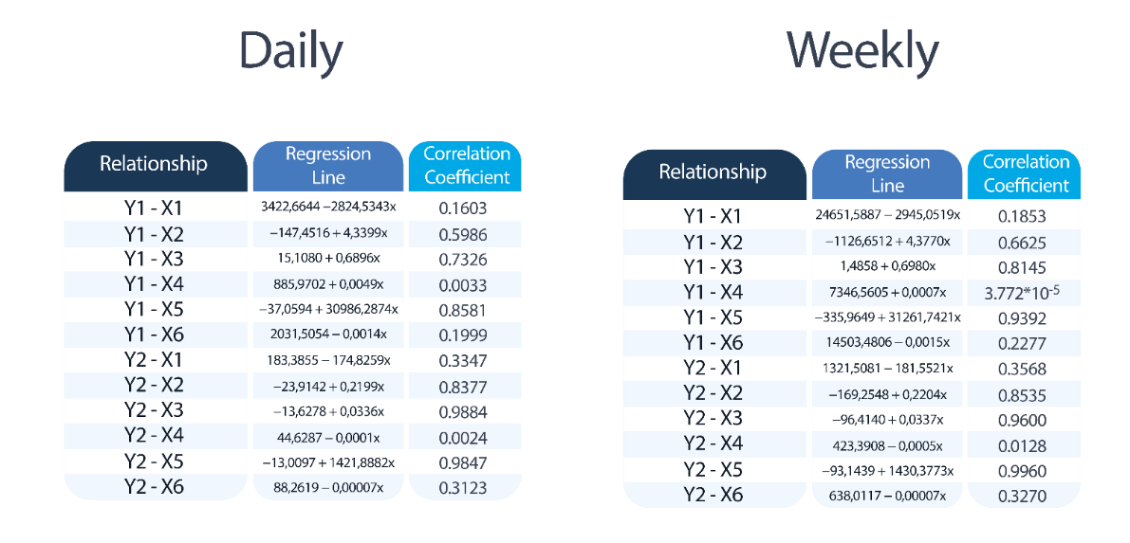

**Daily Analysis**

**Y1-X5**

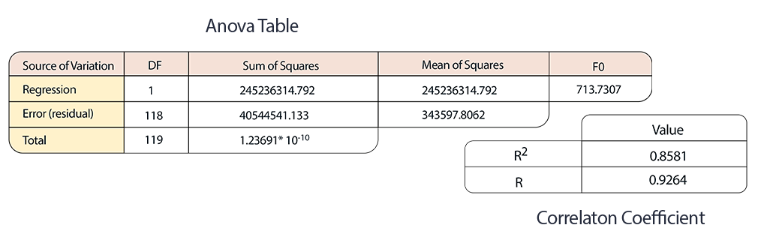

As the tables, indicate, the CC is higher than 0.80 which means that 85.81% of the data variation is explained by the regression. This result is confirmed in the Anova table as its results are congruent with a linear regression.

**Y2-X5**

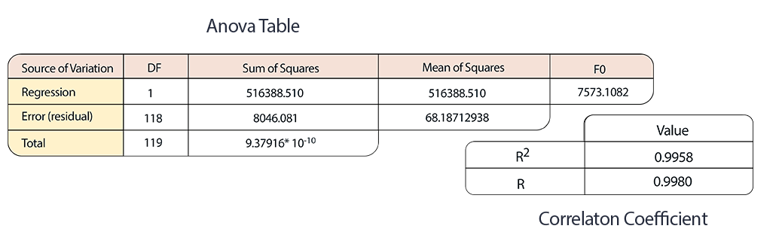

As the tables, indicate, the CC is higher than 0.80 which means that 98.47% of the data variation is explained by the regression. This result is confirmed in the Anova table as its results are congruent with a linear regression.

**Weekly Analysis**

**Y1-X5**

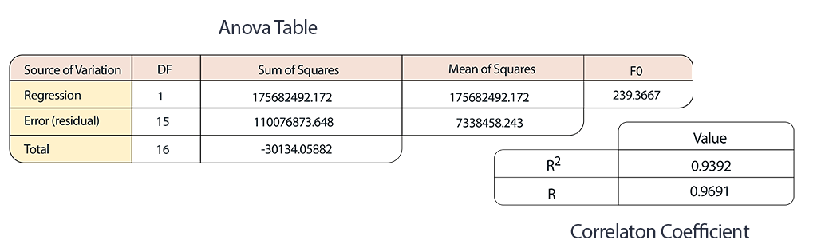

As the tables, indicate, the CC is higher than 0.80 which means that 93.92% of the data variation is explained by the regression. This result is confirmed in the Anova table as its results are congruent with a linear regression.

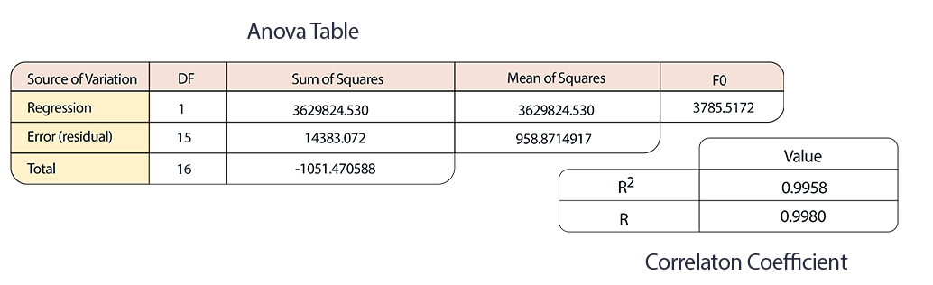**Y2-X5**

As the tables, indicate, the CC is higher than 0.80 which means that 99.58% of the data variation is explained by the regression. This result is confirmed in the Anova table as its results are congruent with a linear regression.

1.2.2. Hypothesis tests for model coefficients

The goal of the Hypothesis Test is to study the relationship and make **decisions** upon the results of it. Here we test if we can consider the values of the paraments to be equal to zero.

So, a Hypothesis Test would look like this:

$$H0: \hat{a}=0 v.s. H1: \hat{a} ≠0 or H0: \hat{b}=0 v.s. H1: \hat{b} ≠0$$

In order to make a decision we have to check whether or not *Ta*/*Tb* is higher than *tc*

$$ta= \frac{\hat{a}- \hat{a}0}{S\sqrt{\frac{1}{n}+\frac{{\overline{x}}^{2}}{Sxx}} } tb= \frac{\hat{b}- \hat{b}0}{\frac{S}{\sqrt{Sxx}} } tc= t1-\frac{a}{2},(n-2)$$

So, if Ta/Tb is actually higher than tc, we **reject** H0.

Here it is a quick overview of the all study, regarding the Simple Linear Regression.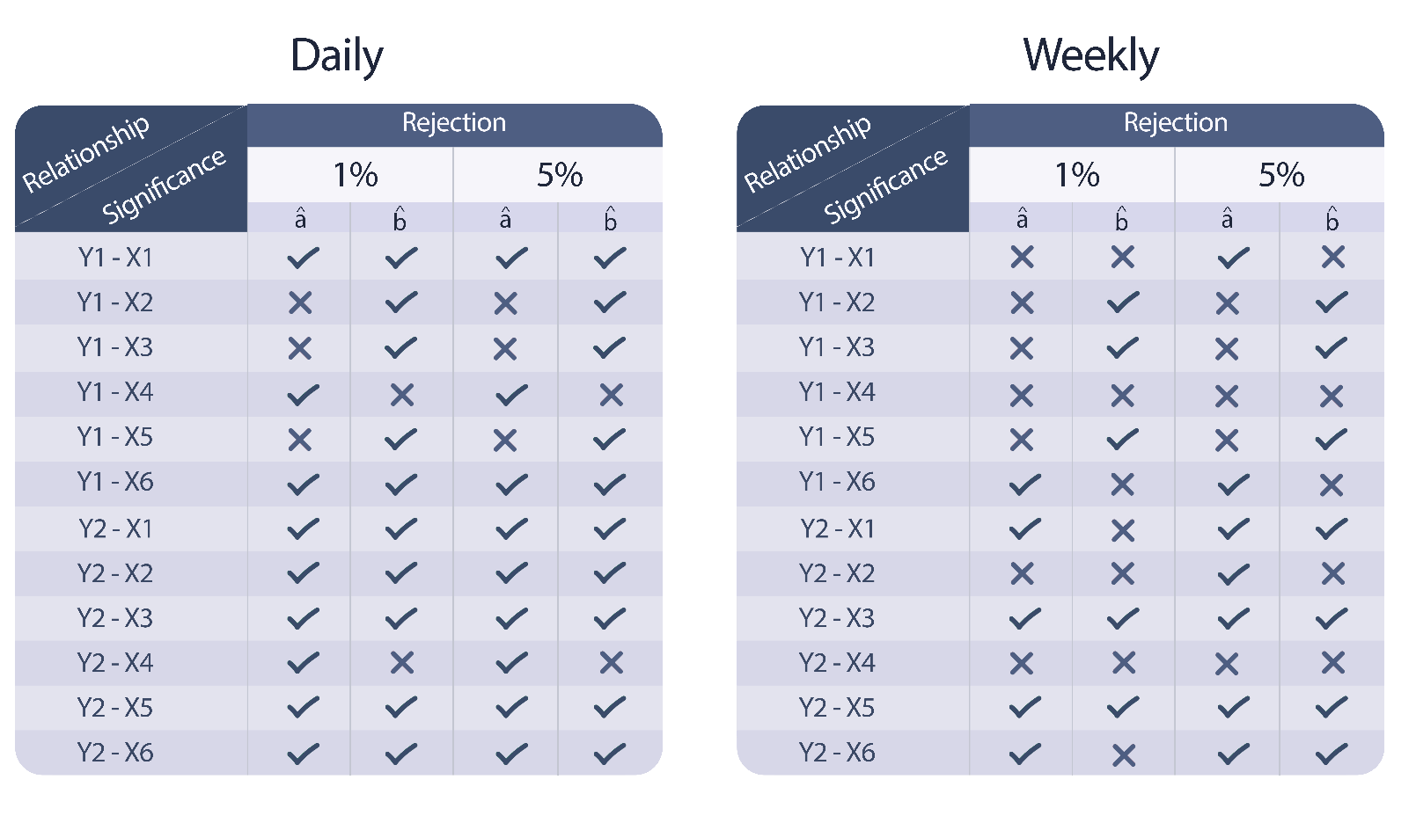

As we can see, the high correlations coefficients reflect these decisions. The majority say we can reject H0, meaning that the parament is different from zero.

1.2.3 Confidence intervals for prediction values

The goal of the Confidence Intervals is to calculate an interval, depending on a certain confidence level, where we are sure the value of the paraments belongs to.

So, in order to calculate a confidence interval, we need to specify a confidence interval (it was requests to used 90% and 95%) and determine the *tc* value. Then, we calculate the standard deviation (which depends solely upon the number of samples and the values of the dependent variable). Apply the formula and finally sum and subtract everything the with corresponding parameter.

$$a±tcs\sqrt{\frac{1}{n}+\frac{{\overline{x}}^{2}}{Sxx}} b± tcs\sqrt{\frac{1}{Sxx}}$$

From this, we would obtain an interval, a superior and inferior limit.

Here it is a quick overview of the all study, regarding the Simple Linear Regression

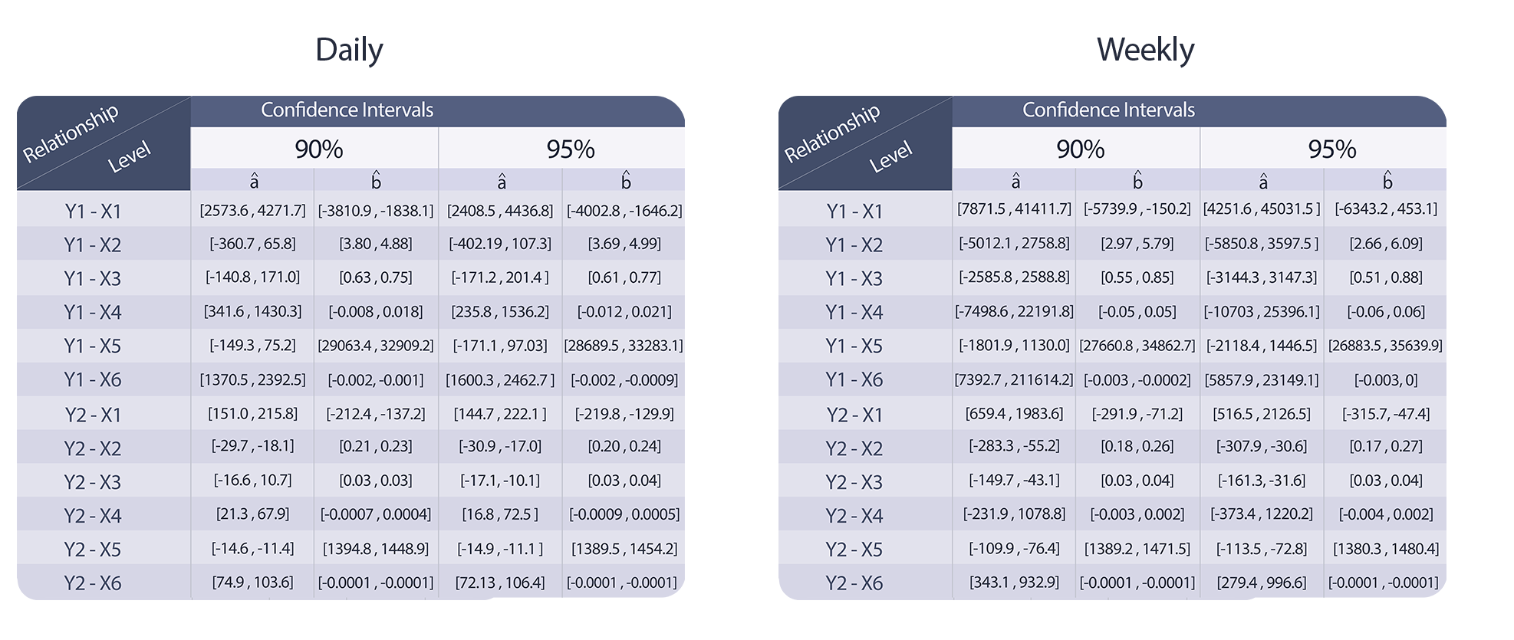

Linear Regression

2 Multiple Linear Regression

2.1 Overview of Multiple Linear Regression (brief theoretical description)

Multiple Linear Regression is also a linear regression model, although, like the name indicates, it uses **multiple explanatory variables**, in opposition of the Simple Linear Regression. The goal of this type of regression is also to study the relationship between these variables (one dependent from many other independents).

Taking in account that MLR works with more than two variables, there is no regression line like the SLR. So, instead, we calculate **correlation coefficients** for each variable. Consequently, the regression model looks like this:

$yi= β0+ β1x1+ β2x2+ β3x3+…+ βkxk+ εi$

To calculate these coefficients, we first need to calculate some **matrixes**.

* **The X matrix** – where the first column is formed by 1’s and the others columns are composed by the values of the independent variables.
* The X matrix **transposed**
* X matrix transposed **times** the X matrix
* The **inverse** of the matrix above.
* Finally, the X matrix transposed **times** the dependent variable values.

Then, by determining these matrixes, we just have to multiple the inverse matrix with the last one mentioned. By calculating these, we will have ***k*** different correlation coefficients.

Once the coefficients are calculated, it is possible to estimate the dependent variable values with given independent variable values.

Like the SLR, on the MLR, to better explore the relationship between these variables, we also estimate these coefficients with **hypotheses tests** and **V**.

Lastly, the **Anova table** is also used to make decisions regarding the results.

2.2 Multiple Linear Regression Model

Similar to the SLR analysis, this one is also divided on a daily and weekly analysis, however, in opposition to SLR, instead of having twelve different relationships, here we only have two (new cases and new deaths will all the others).

As there are two dependent variables and six independents, there are seven correlation coefficients in each relationship.

For each coefficient, there are confidence intervals and hypotheses tests.

Also, there is a Anova table, which contributes to decision making.

For the sake of this user manual, we will only be showing and discus the obtained results.

2.2.1 Model significance

When observing an anova table we make a decision based upon the F0 value. We can conclude that is acceptable to admit that a certain regression is linear if the value of F0 is higher than fα;k;n-(k+1).

After doing the math, we can conclude that the 2 relationships, in both daily and weekly analysis, present high determination coefficients, which means that they explain the data variance well.

The results will be found on the next page (Anova table and Determination Coefficient).

**Daily Analysis**

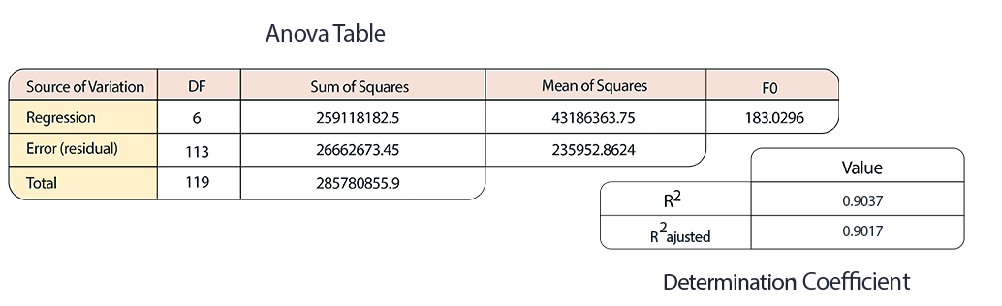**Y1-Xi**

**Y2-Xi**

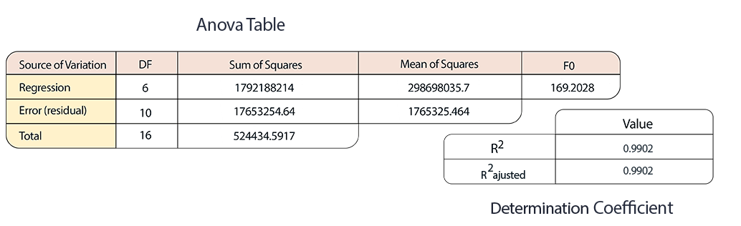

**Weekly Analysis**

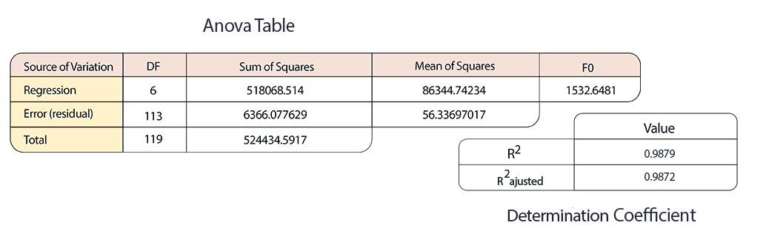**Y1-Xi**

**Y2-Xi**

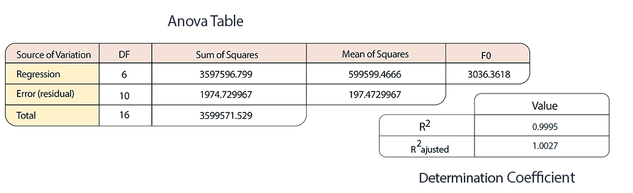

As we can see, all these determination coefficients are **very high**, which translate for an also high *F0* value, which allows us to conclude that there is at least one independent variable that significantly contributes to explain the variation of the dependent variable.

2.2.2. Hypothesis tests for model coefficients

Previously explained in the Simple Linear Regression, the hypotheses tests are used to conclude if we can consider the paraments to be equal to zero. Here, on the Multiple Linear Regression, the goal is the same, the instead of the paraments, we test all the coefficients (βj’s).

So, a Hypothesis Test would look like this:

$$H_{0}: β_{j}=0 v.s H_{1}: β_{j}≠0$$

In order to make a decision we have to check whether or not *T0* is higher than *tc*

So, if T0 is actually higher than tc, we **reject** H0.

Here it is a quick overview of the all study, regarding the Simple Linear Regression.

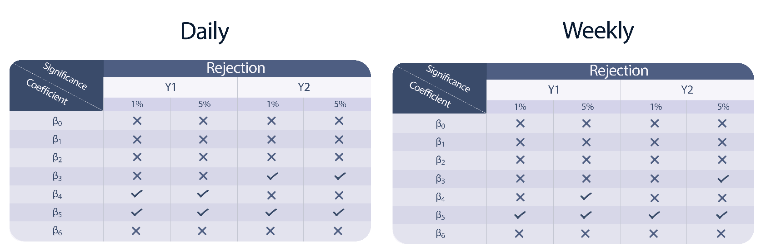

Although the determination coefficients showed incredibly high values, we can see that is not reflected here, because the majority did not reject H0, which allows us to conclude that that coefficient can be eliminated.

We also verify by this study that, the coefficients $β_{4} and β_{5}$ are the most significant.

2.2.3 Confidence intervals for prediction values

The goal of the Confidence Intervals is to calculate an interval, depending on a certain confidence level. It is certain that, in 100 intervals, the value of a certain coefficients is within 90 or 95 of those intervals.

In order to calculate and confidence interval first we need to select the coefficient. Then, we need to calculate the standard deviation and use the corresponding value of the Cjj value.

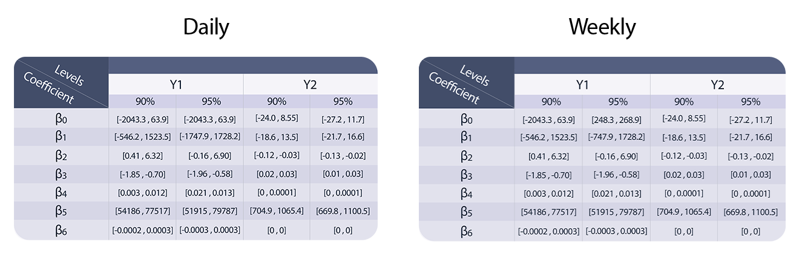

1 Sorting clients by arrival time, or by leaving time

1.1 Introduction (Short introduction to the problem at hands and presentation of the implemented algorithms pseudocode.)

1.2 Runtime tests for inputs of varying sizes (For varied-length time intervals, observe the algorithms execution time, complementing it with a graph presenting the asymptotic growth of the execution time, according to the input size.)

1.3 Worst-case time complexity analysis (Analysis of the time complexity in the worst case of each algorithm, accurately explained.)

2 Evaluation of the effectiveness of the vaccination center’s response

1.1 Introduction (Short introduction to the problem at hands and presentation of the pseudocode of the implemented brute-force algorithm.)

1.2 Runtime tests for inputs of varying sizes (For varied-length time intervals, observe the algorithms execution time, both the implemented and the reference one, complementing it with a graph presenting the asymptotic growth of the execution time, according to the input size.)

1.3 Worst-case time complexity analysis (Analysis of the time complexity in the worst case of the developed brute-force algorithm, accurately explained.)